**Note of the LINK Network meeting held on 9 May 2019 at the Friends Meeting House, Edinburgh.**

**Attending:** Charles Dundas (WTS, LINK Chair, Woodlands Sg Leader), Helen Senn (RZSS, LINK Trustee), Paul Walton (RSPB, LINK Trustee, Wildlife Depute), Sam Gardner (WWFS, LINK Trustee), Beryl Leatherland (SWLG, LINK Trustee), Helen Todd (RS), Isobel Mercer (RSPB), Aedan Smith (RSPB, Planning Group Convenor), Arina (WTS), Mel Nicholl (JMT), Kevin Lelland (JMT), Bruce Wilson (SWT, Economics Group VC), Matthew Crighton (FoES, Economics Group Convenor), Calum Duncan (MCS, Marine Group Convenor), Alistair Whyte (Plantlife), Dougie Peedle (SWT), Helen Taylor (RZSS), Arina Nagy-Vizitiu (WTS), Anna Brand (RSPB, Food and Farming depute), Pat Monaghan (Hon Fellow), Deborah Long (CO), Phoebe Cochrane (SEPO), Daphne Vlastari (AM), Dilraj Watson (AO), Miriam Ross (FFSN Coordinator), Calum Langdale (Species Champions Coordinator), Karen Paterson (FOM), Alice Walsh (DO), Lisa Webb (AAO)

**Apologies**: Craig Macadam (Buglife, Vice-Chair), Clare Symonds (PD, Trustee), Lloyd Austin (HF, Governance Group), John Mayhew (APRS), Liz Ferrell (Bat Conservation), Eddie Palmer (Scottish Badgers, Wildlife Crime), Tim Ambrose (Treasurer), Lucy Graham (Trustee), Suzanne Burgess (Buglife), Pete Ritchie (Nourish, Food and Farming), Andrew Bachell (JMT).

1. **Introductions and general LINK updates**

Charles welcomed everyone and outlined the purposes and structure of the day.

Updates from the Advocacy Team followed.

**Brexit implications**: Please also refer to the [Political Strategy Report](http://www.scotlink.org/private-docs/link-political-strategy-report-april-2019/) on the members part of the website. Daphne summarised the political context domestically, UK and internationally and what some recent developments mean for our work. Brexit remains a key risk for protection of the environment. We have got some safeguards from Westminster and Scottish Govt, but we need to keep pushing. There has been additional work to prepare for the EU elections, including preparation of a LINK [manifesto](http://www.scotlink.org/public-documents/scottish-environment-link-manifesto-for-the-2019-european-parliament-elections/).

Scottish Independence was back on the agenda, with implications for our messaging: for example, Roseanna Cunningham’s position on the Green New Deal is that we need the full powers of independence for its delivery.

Internationally, the publication of the Global Assessment of Biodiversity and the IPCC report on Climate are out, and we are using them to inform, enhance and accelerate performance in Scotland. There are some important international conferences ahead in 2020, IUCN World Congress in Marseille and the COP on Biodiversity, and we want to be aligned with NGO colleagues.

Recent positive news is the new target of net zero by 2045, and the Climate Change plan, and enhancing nature-based solutions to the climate emergency. It is an opportunity for LINK to make sure these strands are integrated. There is good news on the FFSN campaign, it has been confirmed that SGovt will introduce a bill to realise the commitments made in the Continuity Bill (which LINK earlier influenced). The consultation closing on 11 May will determine what will be in SGovt’s plans. There are concerns about the governance aspect, hesitancy about a new Watchdog, so we are commissioning research on why it is needed. There is concern too about plans for ‘keeping pace with the EU’ powers, and for ensuring that what we are calling for in the Environment Act is aligned here. There is a reluctance from Govt to commit to new targets for nature. This might be due to the service being stretched, or for other reasons. We may need to rejig our priorities to push harder on this.

We expect an Agriculture bill by the year end and are working to ensure it brings the changes we want to see from the current system. A meeting with Fergus Ewing is arranged for June to get some clarity. We are working on the Circular Economy for a Fairer Footprint project, focussing on the key issues we want in the bill, an additional stream of work. Climate, resource and nature strands; we must make sure they speak to each other properly -a matter of coordination. On marine, still work on Protected Areas and the new Fisheries paper. UK Govt is engaged in similar processes, and sensitivities around devolution are still quite clear. SGovt’s view is that it would require a legislative consent motion on the UK bill. There is lack of clarity about the new body Westminster seeks to set up and how Scotland would engage, with sensitivity from Scottish Govt that metropolitan eNGOs (as opposed to Scottish ENGOS, something of a turnaround!) don’t understand devolution.

SGovt is sensitive to criticism. We have made good progress with the Cabinet Secretary Roseanna Cunningham. She will address the LINK reception on 5 June, and she spoke at the LINK fringe at conference. There is work to be done. Our messages are being picked up strategically. We have very good working relationships with the Finance and Constitution and ECCLR cttees, better than 6 months ago. There is more work to be done to equip MSPs on those committees to defend the need for an effective watchdog.

**Fight for Scotland’s Nature campaign**. Miriam explained that the focus has been on the consultation (closed 11 May). Many members signed up to the LINK submission and about 20 other organisations supported LINK’s views in their submissions. On public support, 3 petitions were running; LINK, WWF Scotland and 38 Degrees. So far there were c17k signatures (over 22k by the deadline), which was very good. This has been achieved by members pushing it to their email lists and by social media promotion. Miriam thanked everyone for their work. There has been some media coverage from mainstream and other media. The aim was to hand over the petition to the Cab Sec for the end of the consultation, if she was willing. We have children who are keen to take part. From the LINK petition we have a lot of contacts that are happy to be contacted again, so can keep the issue on the agenda. Post 11 May the priority will be to get more organisations and community groups to support the campaign. There is continued engagement with MSPs, with effort to get them to support the campaign, tied to Species Champions, and action planned over the summer.

**Climate Bill**: Dilraj explained how LINK and WWF Scotland co-produced the Nature on Red Alert report distributed in January, which was picked up well by the media and MSP, including by Species Champions, and mentioned by Alison Johnstone MSP in her speech on the climate emergency. This has opened up what we can do in terms of nature-based solutions. We submitted evidence to the ECCLR cttee on 2 fronts: reduction of emissions and on nature-based solutions, eg National Ecological Network and Marine Protected Areas, and given the CCC report on 2 May, indicated that Scotland has more scope for nature based solutions, a very good angle to take, which ties in with a potential Red Alert 2 report, and development of forestry, agro-ecology, peatlands. On climate adaptation, we revisited earlier work, and submitted a response to the [consultation on Adaptation](http://www.scotlink.org/public-documents/link-response-to-climate-change-adaptation-programme-2019-2024-consultation/). We have tied in these asks as best we can. Keeping in mind the UN report that 1m species are likely to become extinct, there is the opportunity to gain traction on the biodiversity emergency too. Based on all this we have been invited to give evidence on solutions to the ECCLR.

**Charles invited questions and comments.**

Matthew added to the announcement on the Deposit Return Scheme and SGovt’s backdown on the Air Passenger Duty as further reasons to be buoyed up. On the Circular Economy workstream, the Economics Group will shortly be writing out to all members for support, in urging Govt to pass a good bill. On the bigger picture, with the changing feel around emergencies, this is our opportunity to put in our views about how to live on the planet without thrashing it. This is a challenge and he advised we have a lot of thinking to do about how. For example we can say how to get a CE in the short term, but not the long term. Looking after humans and looking after the planet needs a lot more thought.

Paul agreed that it’s a critical moment that gives us unique traction. Doors are a little more open than previously. He asked it was tactical to be asking now for long term legally binding targets for nature, and to push this in the media. Answer, Yes! See LINK’s [blog to the report](http://www.scotlink.org/link-thinks/global-biodiversity-report-where-does-scotland-stand/) which was issued to the media, asking for stronger laws and better implementation of existing laws. **We are looking for more strategic, ambitious and binding targets to ensure our ambitions are met, and importantly are resourced.** The SNH LINK Board to Board meeting had been held. Paul sensed that the FFSN campaign was starting to sting, which was good. He detected a desire from SGovt to say we are in the lead on biodiversity anyway, so in terms of losses, we need to consider historic losses. On peatlands, a classic nature based solution to climate change, there is a huge distance to go. SGovt will want to say Scotland is doing okay, but if looking at the drivers of decline globally, we face the same ones in Scotland. We are more privileged partly because of EU laws, but there can be no resting on laurels. The good news is that we have a lot of the levers and tools to fix things and relatively fast.

Sam, noting how we now have an engaged campaign base, urged that we don’t leave it to wither. So this means establishing a new way of working for LINK, we should have a mind towards the Programme for Govt. We are going to have to prioritise, if we want to see a PfG that speaks to the nature agenda as well as other agendas. **We have to demonstrate our ability to change what our plans are, and we need to be much more responsive to these external circumstances.** He agreed we need to pop the bubble of ‘world leading’, we always had to walk the line between good and bad examples. On biodiversity there is a massive job to be done. For climate we have 2045 as the end point, and no time target is set for biodiversity. We need to act quicker than the State of Nature report. He suggested getting **someone to speak to the Global Assessment report and the situation in Scotland, to help create the political space for a target.**

Calum agreed with what had been said so far, adding the Oceans emergency which was not always so well reflected in State of Nature. The narrative on overfishing at sea is not so clearly heard, so he logged it here. He said the **Marine Group is ready to be bold in its response to the Fisheries paper,** to frame it in terms of the global situation. We need system change, proper seabed use, carbon neutral fishing.

Phoebe said the CE project relates to a lot of this. There is much useful evidence recently in terms of resource use impact. 90% of damage is attributable, and our carbon footprint is flatlining relating to the products we import and consume and how the economy works. **We will push for a CE bill that will reduce overall material and carbon consumption.**

Daphne reported we are considering whether we can **arrange a shadow meeting of the Beijing meeting** at the end of 2019, possibly with Tom Watson.

Lobbying register compliance by LINK as a network. Lisa gave an update (see slides below). Everyone has been great about sending her returns, and she asked them to continue with that; setting out where the meeting was, who you met, and what it was about. The register has over 5k returns, is basically inundated, so we are asked not to include exemptions. We have gone above and beyond what is required and will continue to collect all information from members and officers etc, though she submit returns on what is actually required which is where LINK staff are present. There will be a review of implementation in March 2020 and we will gather views ahead of that.

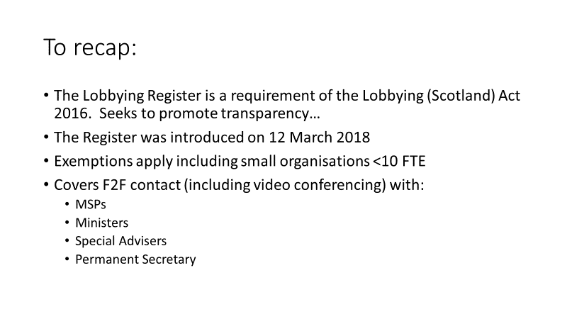

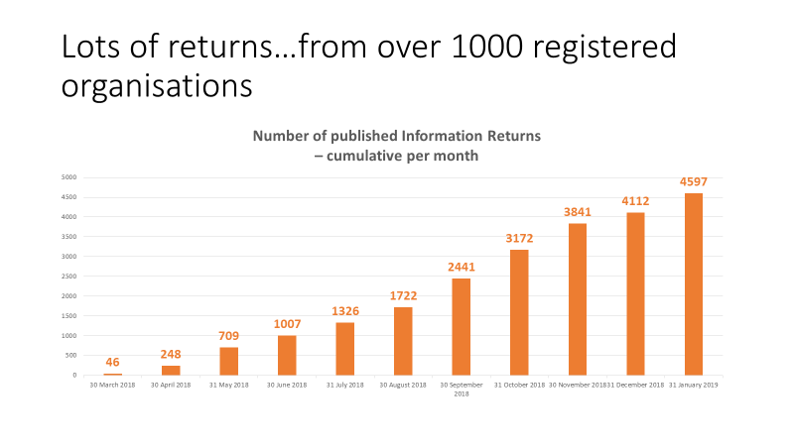

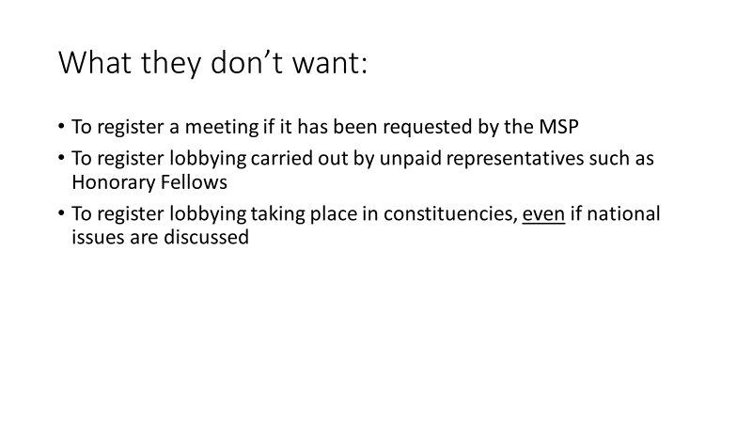

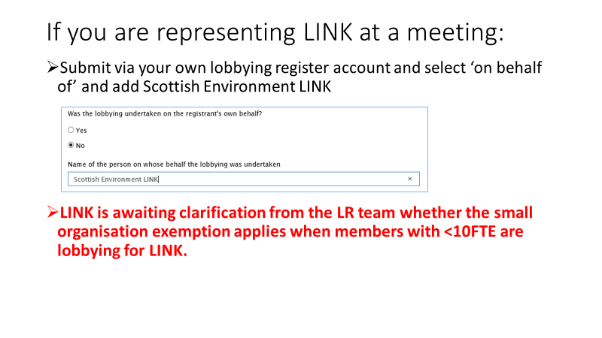

**Exercise 1 – Member Mapping: who are we and what are we doing?**

Deborah invited members to check or allocate their organisations work around 8 key issues: Land, Marine, Planning, SEFF, economics, social justice, On the edge. The aim is to cross check with LINK’s priorities to ensure we are prepared as member bodies and as LINK, to push at the doors that are opening as a result of the Schools Strikes, N Sturgeon’s announcement of a climate emergency and the UN’s Global Assessment of Biodiversity with its ask for transformational change. She set out the ground rules we have to obey; to be coherent and truthful, concise and targeted, solutions focussed, united in message and approach, so that politicians can act in the space that is opened. We can do a lot of work as LINK. We are still seen by others as being too noisy and disputatious amongst ourselves. Members spent the next 30 minutes doing this exercise, adding what their organisations were doing. Results are summarised in the Member priorities by Group tab in the Group map 2019 spreadsheet.

**LINK’s 10 year vision: what do we want to see in 10 years time?**

Deborah had provided some tools for Inspiration, including LINK’s 2013 Referendum Challenge as a starter, to start to build a vision for LINK, to articulate what we want to see.

*A serious surfer doesn’t plan to go surfing at week next Tuesday at 2, they go when the wind and the tide are right.*

Members were asked to add their thoughts to the flipchart during lunch. The word cloud reflects that input.

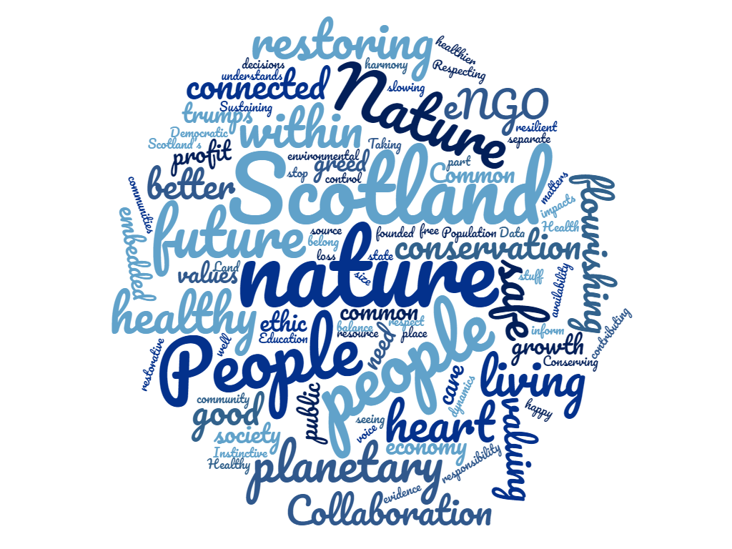

After lunch members considered LINK’s **3 strategic objectives** to stress test them to ensure they are what we need and that members can see themselves in there. The current objectives are:

* A Sustainable Scotland
* Being a strong voice for Scotland’s environment
* Operating as an effective, efficient and accountable network.

Discussion covered:

In terms of climate is a sustainable Scotland a bit insular? There was some feeling we need to show we are outward looking, that as a wealthier nation there is an imperative to do more on limiting emissions. We might add something about planetary boundaries. There was broad approval of sustainable, Bruntland defined, which has the benefit of being intergenerational and international. Suggestions were to be more inspirational; be clear where we can have an effect and where our responsibility lies; Footprint is a useful term for connecting people to their effect on the rest of the world. The existing frame is protecting nature, and to do that we have to protect people as well. One Planet Scotland was a suggestion though that may not challenge Scotland on some levels. A small country as an exemplar though we have a problem with our ‘world leading’ Govt, it played well recently with the ECCLR Cttee. Members liked the way that Referendum Challenge translated the generics into a vision. All were agreed on the global aspect.

On the strong voice, it’s not just strong, it is a common voice. The value is in its unity.

It was agreed the themes are pretty good as they are, and Deborah would incorporate the thinking in this **revised version**:

A sustainable* Scotland, leading by example

Being a strong voice for Scotland’s environment

Operating as an effective, efficient and accountable network

\***Sustainable***development is development that meets the needs of the present without compromising the ability of future generations to meet their own needs. Bruntland report 1987*

**Action: all to respond to Deborah with comment on the above.**

**Exercise: Group/Subgroup mapping**  
Members then moved back into groups and subgroups to sense check their existing plans for this year (2019-20) and to propose plans for the following 2 years. They were provided with examples of advocacy plans and blank DPF forms if more resources were needed. Groups reported back. Results are summarised in the Detailed Group actions tab of the Groups maps 2019 spreadsheet.

Issues for LINK to consider more widely that emerged from discussions included:  
the need for better cross fertilisation between groups, and more regular inter-group meetings. This will ultimately save capacity.   
NEN runs through at least 4 groups.   
Landscape as an asset is potentially a new idea.   
The Rhetoric versus Reality gap (between environmental laws and their effective implementation). All groups should have this in their heads and what needs to be done to stop it.

Deborah would write up the plans from the flip charts. It will be useful if all groups and subgroups can ensure they make the links to other work areas and ensure we are not doing the work several times.

**Convenors – please share with your Groups and Subgroups and make any further amendments by 28 June.**

**Summary:** Charles thanked everyone for their contributions. It was heartening to hear all the things we are able to engage with. He asked those present to respond to the papers that will come back from this meeting, much of which will feed into a new piece of work, a 10 year plan for LINK. This will be clearer about where we actually want to get to, versus where do we realistically expect to get to. There will be a report back to Congress on 17 September on this process. The Board will look at it again in October and it will be on the agenda for the 12 December Strategic Planning meeting (followed by the Festive Reception in the evening).

**Any other Business**

1. Members were encouraged to nominate people and projects for the **Nature of Scotland Awards** by 4 June.

2. Paul asked for **volunteers over the summer to take authorship of short chapters** about one side of A4 for the **State of Nature Scotland** report. This is a 3 yearly objective analysis done by a coalition of NGOs, to take a snapshot of biodiversity, due for publication this autumn. There will be a standalone publication for Scotland. Need people to be authors to chapters, a side of A4, and authors will be given access to all the data. These include chapters on agriculture management, on climate change, woodland management, marine, fisheries and built environment. need people in the summer to do it. **Please contact Paul** with offers - paul.walton@rspb.org.uk